QTester User Manual

Table Of Contents

1. Introduction to QTester 1
2. Configuring Data for use in QTester 1
3. Running QTester 2

Introduction to QTester
QTester is an application which is used to measure the decision response time of a candidate when presented with a sequence of Video information.

Configuring Data for use in QTester

QTester require a ‘media sequence’ file, which specifies the videos which will be used for analysis, the acceptable responses from the user, and the correct response. This data needs to be presented in the following format:

<VN><bs><T1><bs><K1><bs><T2><bs><K2><bs><T3><bs><K3><bs><T4><bs> <K4><RG><nl>

Where:
VN := Video Name (No blank spaces are permitted in the name)
bs := Black Space (i.e. “ “)
T1 := The label for option 1 for the user (i.e. “Outswinger”)
K1 := The keystroke the user will use to input option 1 (i.e. “q”)
T2 := The label for option 2 for the user (i.e. “Inswinger”)
K2 := The keystroke the user will use to input option 2 (i.e. “w”)
T3 := The label for option 3 for the user (i.e. “Straight”)
K3 := The keystroke the user will use to input option 3 (i.e. “o”)
T4 := The label for option 4 for the user (i.e. “Bouncer”)
K4 := The keystroke the user will use to input option 4 (i.e. “p”)
RG := Specifies which is the options is the correct response
nl := A new line must be started

This may be repeated for a maximum of 100 videos per a file. There should always be a blank line on the last line of the file.

A sample file, would look like this

TP(A)T04.mpg OutSwinger q Straight w SlowerBall o InSwinger p 1
TP(A)T13.mpg OutSwinger q Straight w SlowerBall o InSwinger p 2
TP(A)T26.mpg OutSwinger q Straight w SlowerBall o InSwinger p 3
TP(A)T36.mpg OutSwinger q Straight w SlowerBall o InSwinger p 4

The file must be saved with a “.csv” extension. The videos that will be used by this file, must also be stored in the same directory.

Running QTester

- To run QTester, navigate to the directory where it is installed, and run the program ‘QTester.exe’.
- Once the program has started, it will request the user to input the file name where the results from the experiment will be stored (see Fig 1). This file can be stored any where on the computer locally (it is advised NOT to store it on a network drive, as this may impact the timing for the results gathered). The file should have a “.dat” extension.

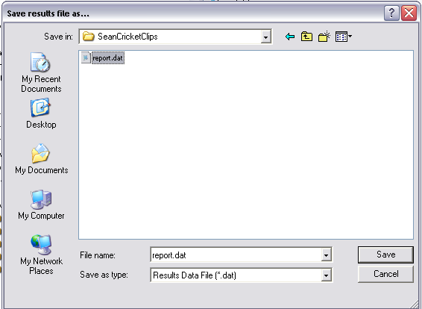
Figure 1 - Specify Results File

- The user will now be requested to specify the configuration file for the experiment (see Fig. 2). This is the file that was created in section 2. The user will need to navigate to where the file is stored and select it.

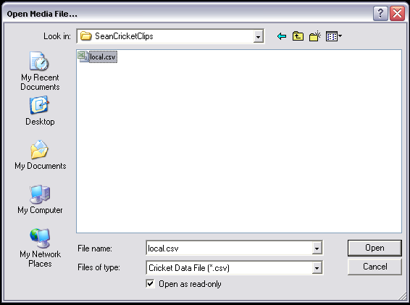
Figure 2 - Configuration File

- Before each video is run, the user will be presented with a dialog box, indicating the valid options for the video (See Fig. 3). To commence the video, the user may navigate the mouse courser to the ‘OK’ button and click it (not recommended, as this will mean the user ahs to quickly get their hands in place to select the options), or click the ‘Enter’ key on the keyboard (recommended). The video will start immediately.

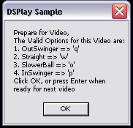
Figure 3 - User Options

- The user will be presented with a screen as shown in Fig. 4. Before the video completes, the user must enter a valid input (from the options). If not a “NULL” option will be recorded for the user, and the maximum video time recorded as the response time.

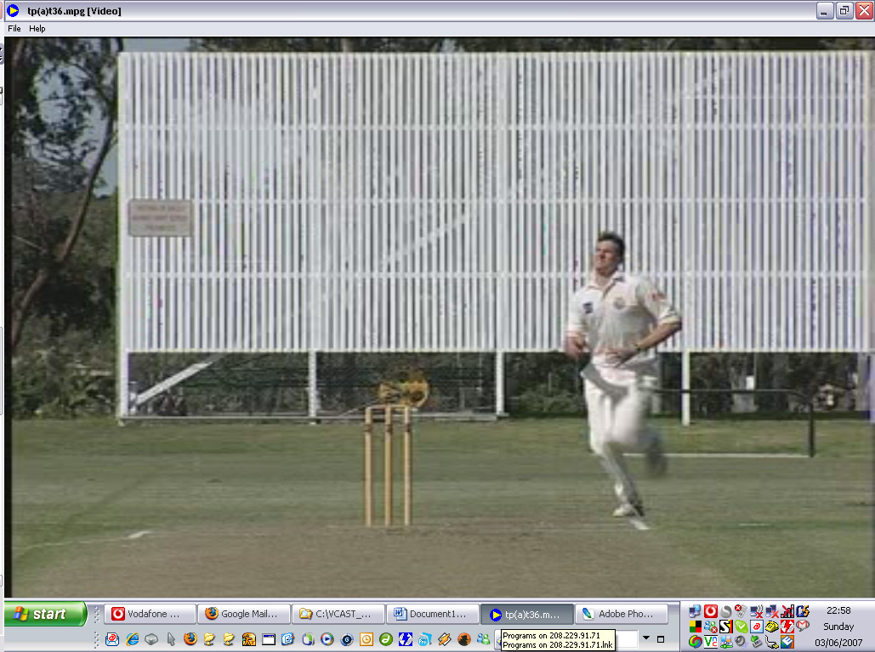
Figure 4 - Active Video

6. Steps 4 and 5 will repeat until the video sequence completes.

7. Once the video sequences have finished, the user will be presented with the dialog below, to finalize the results file and exit the program.

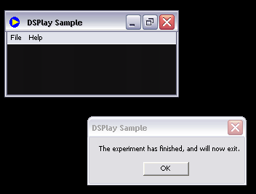
Figure 5 - Exit Dialog

